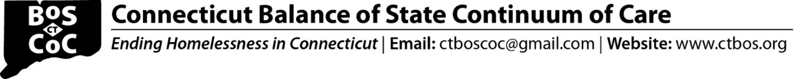

FAQ for Unsheltered & Rural New Project Application

- Question: How does HUD define Severe Service Needs?

Answer: Severe Service Needs means any combination of the following factors: facing significant challenges or functional impairments, including any physical, mental, developmental or behavioral health disabilities regardless of the type of disability, which require a significant level of support in order to maintain permanent housing (this factor focuses on the level of support needed and is not based on disability type); high utilization of crisis or emergency services to meet basic needs, including but not limited to emergency rooms, jails, and psychiatric facilities; currently living in an unsheltered situation or having a history of living in an unsheltered situation; experiencing a vulnerability to illness or death; having a risk of continued or repeated homelessness; and having a vulnerability to victimization, including physical assault, trafficking or sex work.

- Question: Can we do a combination Drop-in and Street Outreach Program?

Answer: Unfortunately, no. If selected, applicants will need to submit these separately. See HUD explanation below.

- Street Outreach. Applicants should select this SSO subtype if the project will fund street outreach activities. Street outreach offers services necessary to reach unsheltered homeless individuals and families to connect them with emergency shelter, housing, or critical services and provide urgent non-facility-based care to those who are unwilling or unable to access emergency shelter, housing, or an appropriate health facility.
- SSO-Other. Applicants select this SSO subtype if the project will fund stand-alone support services to individuals and families experiencing homelessness or who have been homeless in the prior 6-months but are now residing in permanent housing (that is not PSH or RRH). This means, the recipient is providing supportive services to individuals and families experiencing homelessness for whom the applicant is not also providing housing or housing assistance. Examples of stand-alone supportive services include (1) housing navigation activities for people experiencing homelessness when the applicant is not also providing any ongoing housing assistance (e.g., rental assistance), (2) childcare services to individuals and families experiencing homelessness, (3) drop-in centers that provide supportive services to people experiencing homelessness, and (4) family reunification services to reunite people experiencing homelessness with their families.

- Question: For RRH, since we are not administering rental assistance (RA), is match needed for RA?

Answer: Yes, match is required for the TOTAL budget for the entire project, which includes the RA. This is a threshold factor; the project will not be reviewed unless the match is sufficient.

- Question: We have a PATH funded worker who would assist with outreach and engagement. As I read the instructions this PATH funding can be fully counted as cash match. Do I need a letter from DMHAS now for the NOFA application?

Answer: PATH may be counted towards match. You do not need to include a letter with the application.

- Question: Since services is to be Housing Focused Case Management, which includes flexibility to allow for shared housing placement, does this mean PSH rental subsidies can/will be applied to shared housing placements?

Answer: DMHAS has noted that shared housing placements are difficult to process so they are not encouraged for this application.

- Question: Must applicants commit to hiring persons with lived experience specifically of "unsheltered" homelessness? Subrecipient already gives priority to PWLEH in job postings for all Housing and Homeless Program vacancies. Is this practice sufficient or must it specify lived experience of "unsheltered" homelessness?

Answer: HUD is specifying the unsheltered piece which is why that is included in the BOS application.

